YEAR 10 SUGGESTED REVISION GUIDES – ALL AVAILABLE TO PURCHASE VIA ARBOR
ENGLISH BOOKS, REVISION CARDS, TEXT GUIDES

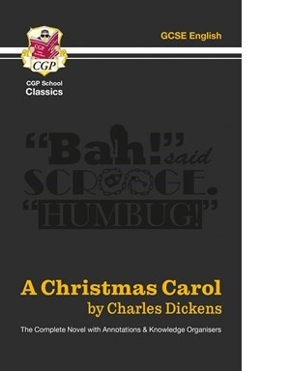 | 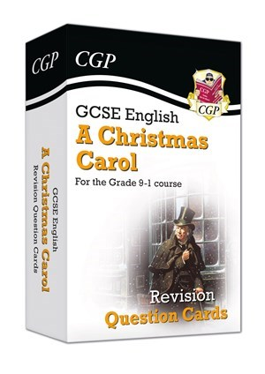 | 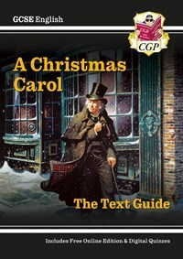
£2.90 | £4.90 | £3.50
 | 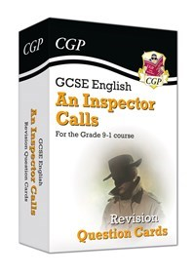 | 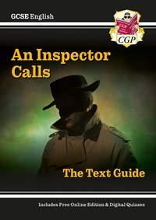
£7.50 | £4.90 | £3.50
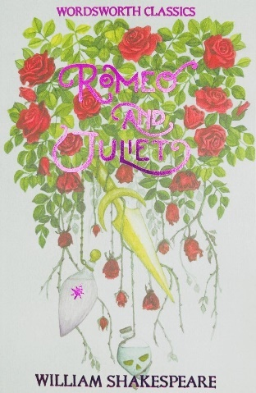 | 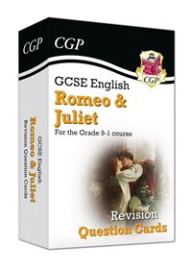 | 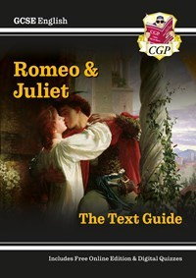
£3.40 | £4.90 | £3.50
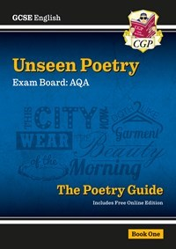 | 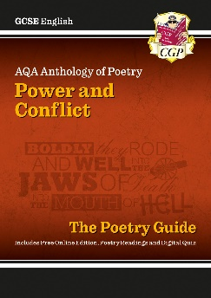 | 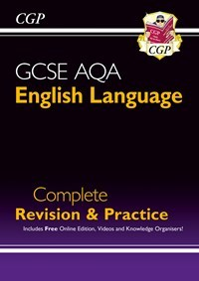
£3.50 | £3.50 | £6.50
MATHS REVISION GUIDES, WORKBOOKS, CALCULATOR

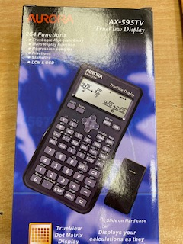 | 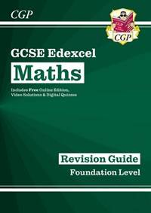  FOUNDATION – IF IN DOUBT, ASK YOUR TEACHER | 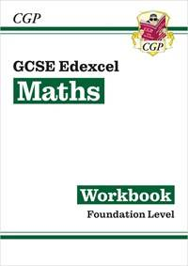  FOUNDATION – IF IN DOUBT, ASK YOUR TEACHER
£9.85 | £3.50 | £3.50
HIGHER – IF IN DOUBT, ASK YOUR TEACHER  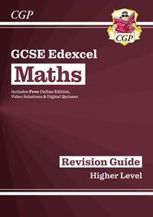 | HIGHER – IF IN DOUBT, ASK YOUR TEACHER  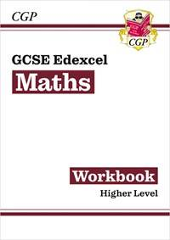
£3.50 | £3.50
SCIENCE REVISION GUIDES, WORKBOOKS

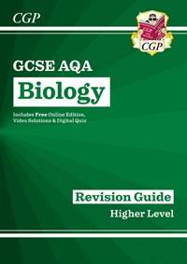 | 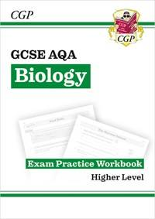 | 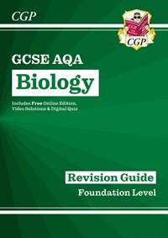
£3.50 | £3.50 | £3.50
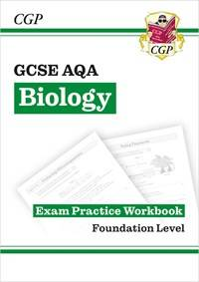 | 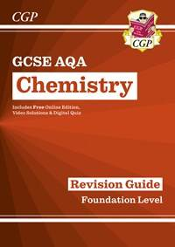 | 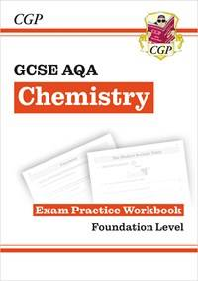
£3.50 | £3.50 | £3.50
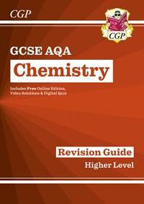 | 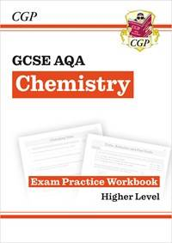 | 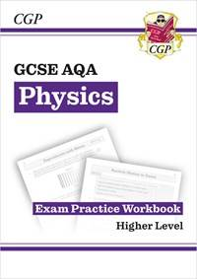
£3.50 | £3.50 | £3.50
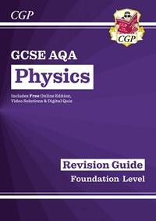 | 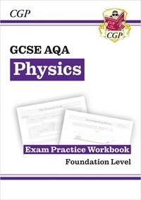 | 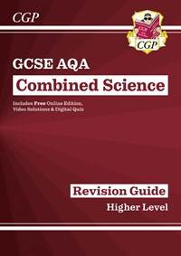
£3.50 | £3.50 | £6.40
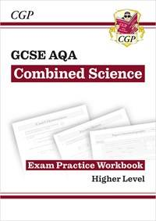 | 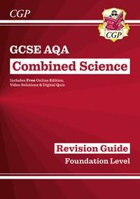 | 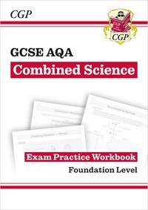
£6.40 | £6.40 | £6.40
BUSINESS STUDIES REVISION GUIDES, CARDS, WORKBOOKS

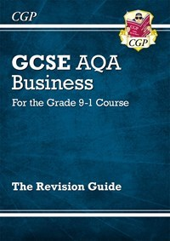 | 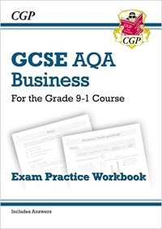 | 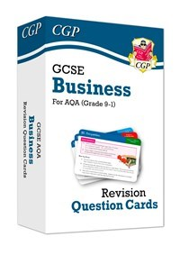
£3.50 | £3.50 | £5.50
COMPUTER SCIENCE REVISION GUIDES, CARDS

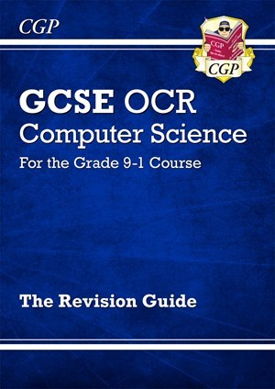 | 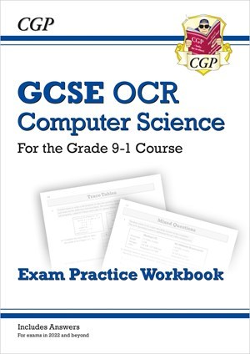 | 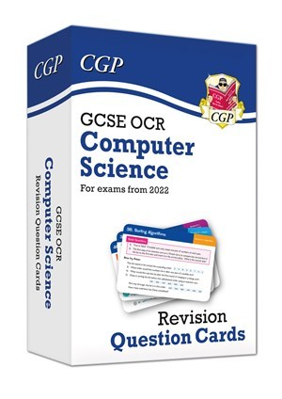
£3.50 | £3.50 | £5.50
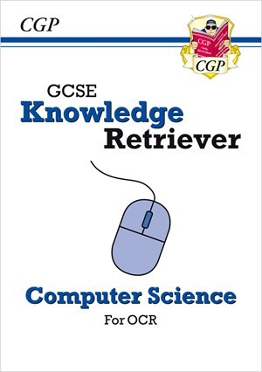

£3.50
GEOGRAPHY REVISION GUIDE, WORKBOOK AND CARDS

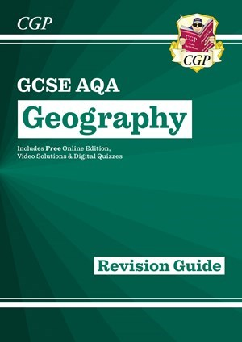 | 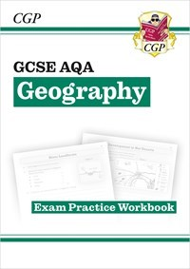 | 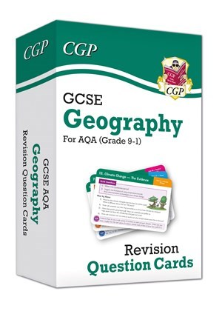
£3.55 | £3.50 | £5.50
HISTORY REVISION GUIDES, WORKBOOK AND CARDS

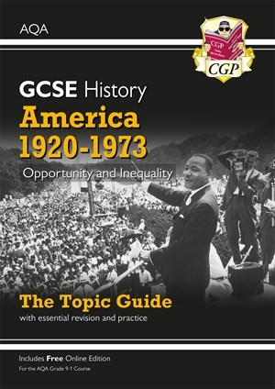 | 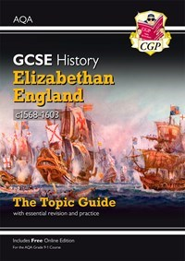 | 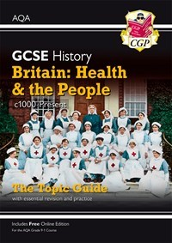
£3.50 | £3.50 | £3.50
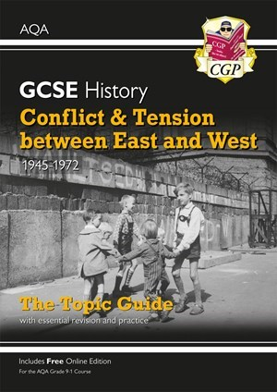
£3.50
P E REVISION GUIDES, WORKBOOKS

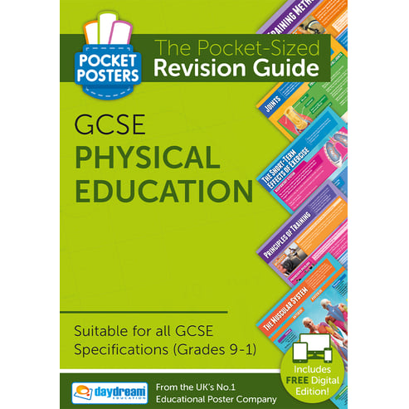 | 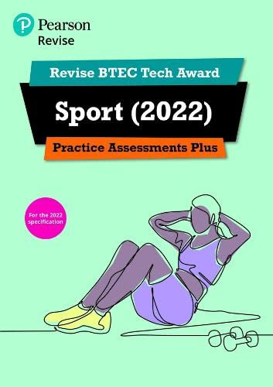 | 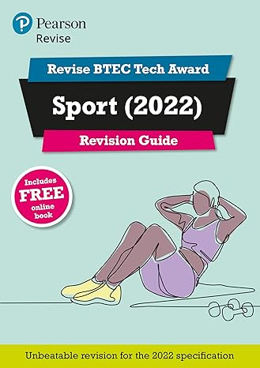
£2.65 | £6.60 | £6.60
MISCELLANEOUS ITEMS

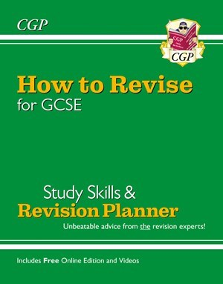 | 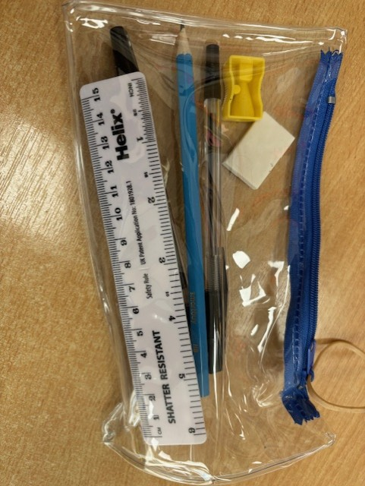
£2.60 | £3.50

