YEAR 11 SUGGESTED REVISION GUIDES AVAILABLE FOR SALE IN THE ARBOR SHOP
ENGLISH BOOKS, REVISION CARDS, TEXT GUIDES

 | 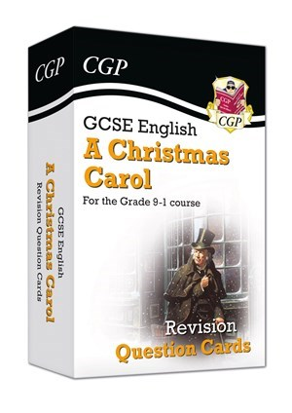 | 
£2.90 | £4.90 | £3.50
 | 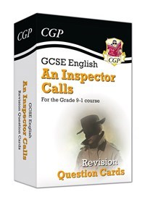 | 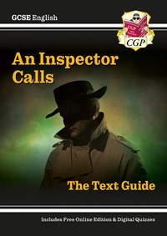
£7.50 | £4.90 | £3.50
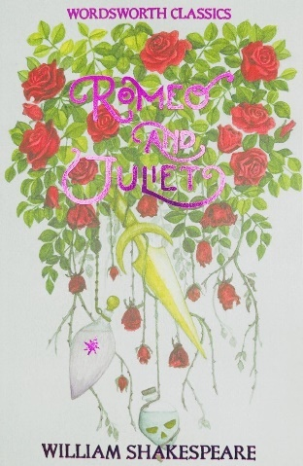 | 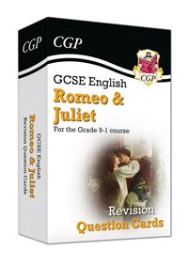 | 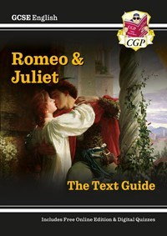
£3.40 | £4.90 | £3.50
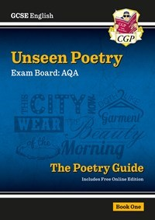 | 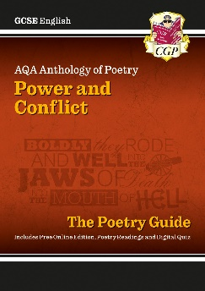 | 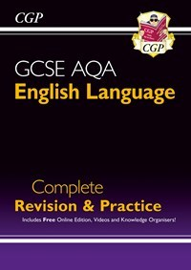
£3.50 | £3.50 | £6.50
MATHS REVISION CARDS, CALCULATOR

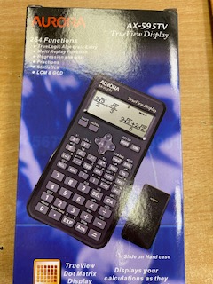 | 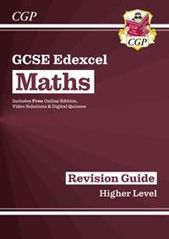  PLEASE CHECK WITH YOUR TEACHER IF YOU NEED FOUNDATION OR HIGHER | 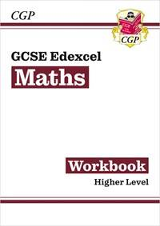  PLEASE CHECK WITH YOUR TEACHER IF YOU NEED FOUNDATION OR HIGHER
£9.60 | £3.50 | £3.50
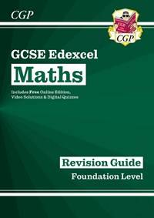  PLEASE CHECK WITH YOUR TEACHER IF YOU NEED FOUNDATION OR HIGHER | 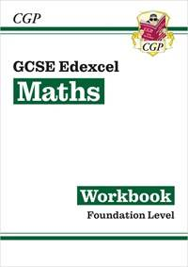  PLEASE CHECK WITH YOUR TEACHER IF YOU NEED FOUNDATION OR HIGHER
£3.50 | £3.50
SCIENCE REVISION GUIDES, REVISION CARDS, WORKBOOKS

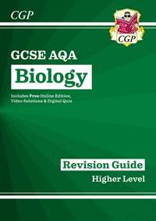  PLEASE CHECK WITH YOUR TEACHER IF YOU NEED FOUNDATION OR HIGHER | 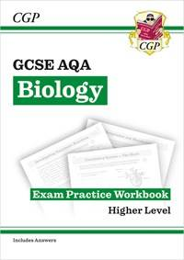  PLEASE CHECK WITH YOUR TEACHER IF YOU NEED FOUNDATION OR HIGHER | 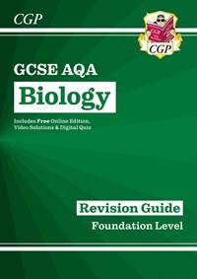  PLEASE CHECK WITH YOUR TEACHER IF YOU NEED FOUNDATION OR HIGHER
£3.50 | £3.50 | £3.50
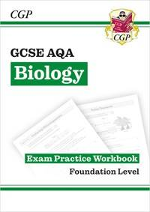  PLEASE CHECK WITH YOUR TEACHER IF YOU NEED FOUNDATION OR HIGHER | 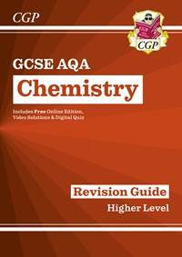  PLEASE CHECK WITH YOUR TEACHER IF YOU NEED FOUNDATION OR HIGHER | 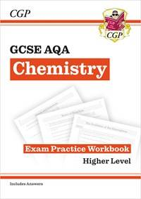  PLEASE CHECK WITH YOUR TEACHER IF YOU NEED FOUNDATION OR HIGHER
£3.50 | £3.50 | £3.50
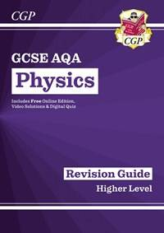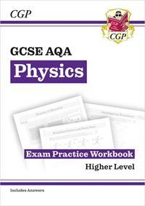 | 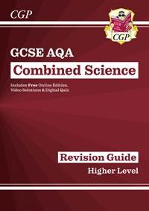 | 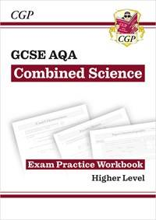
£3.50 EACH | £6.40 | £6.40
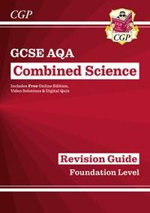 | 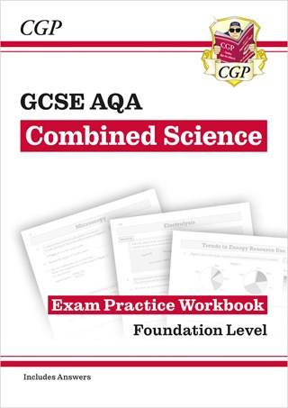
£6.40 | £6.40
BUSINESS STUDIES REVISION GUIDES, CARDS, WORKBOOKS

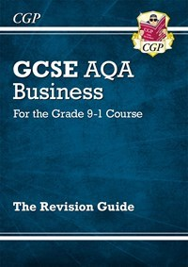 | 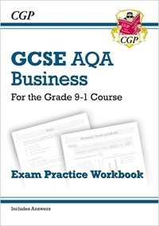 | 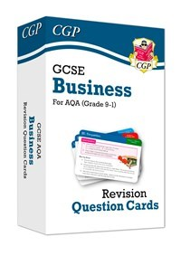
£3.50 | £3.50 | £5.50
COMPUTER SCIENCE REVISION GUIDES, CARDS

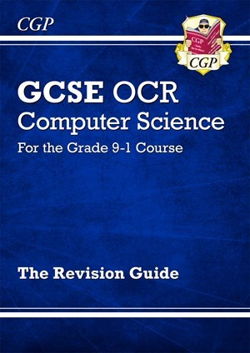 | 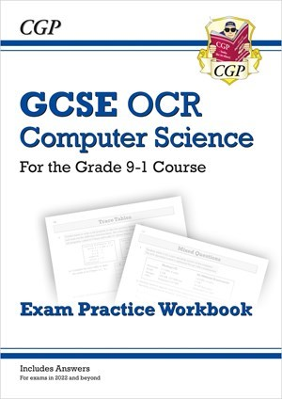 | 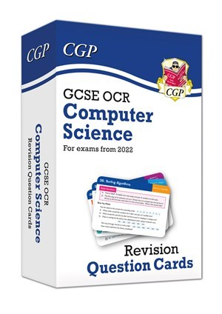
£3.50 | £3.50 | £5.50
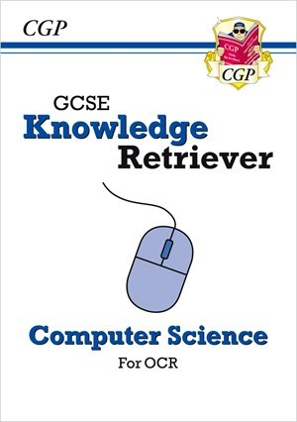

£3.50
GEOGRAPHY REVISION GUIDE, WORKBOOK AND CARDS

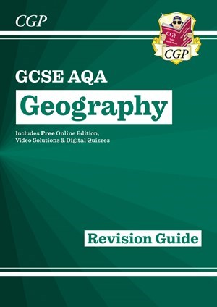 | 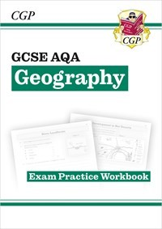 | 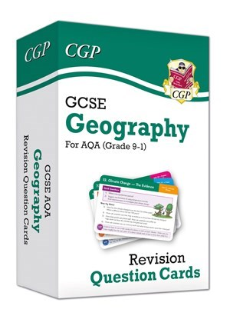
£3.55 | £3.50 | £5.50
HISTORY REVISION GUIDES, WORKBOOK AND CARDS

 | 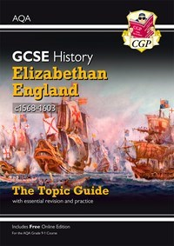 | 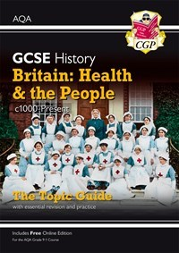
£3.50 | £3.50 | £3.50
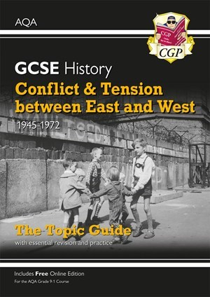
£3.50
PHYSICAL EDUCATION REVISION GUIDES, CARDS, WORKBOOKS

 | 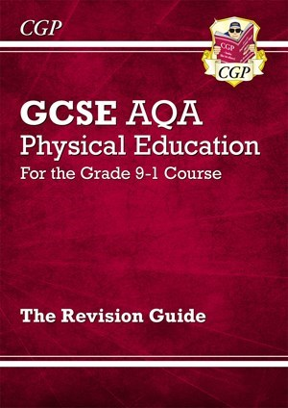 | 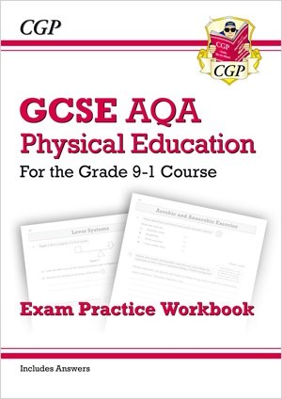
£2.55 | £3.50 | £3.50
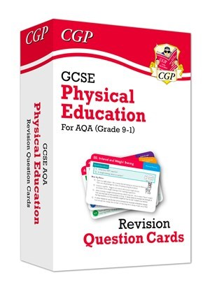 | 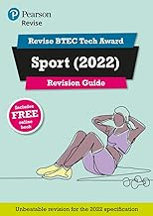 | 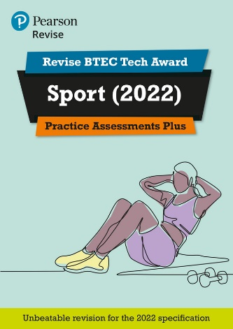
£5.50 | £6.60 | £6.60
MISCELLANEOUS ITEMS

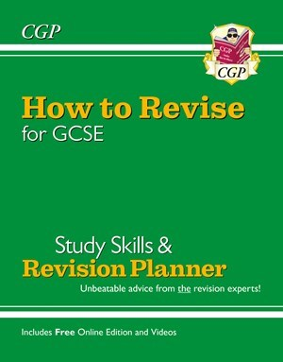 | 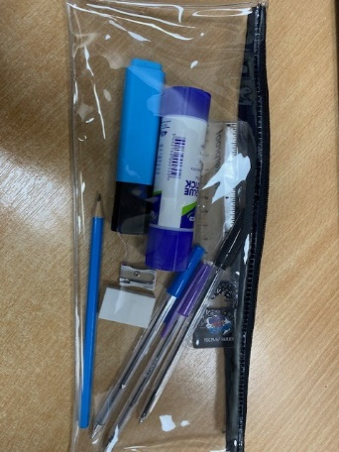
£2.60 | £3.50

